**Project 5: Health DB – Advance Queries (Subqueries)**

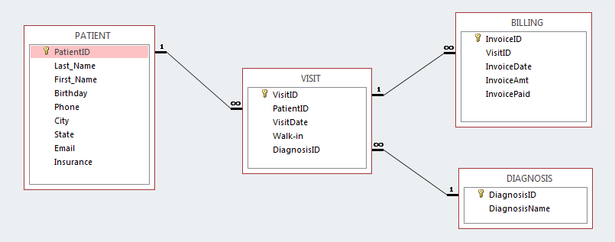

**Important Note:** Please download a new copy of Health DB. It is in the project 5 folder.

**How to start:** In the **Health Database** 🡪 Click create 🡪 Click Query Design 🡪 Close table(s) Box 🡪 Right Click onto Query1 🡪 SQL view on the drop-down list

For More info see the source file in the Project 5 folder under the Files tab.

**Assigned Queries:**

1. List First name and Last name for the patients who visited the health facility more than two times.

Save the query as **Q1Visited**

1. Get the patient numbers and birthdays of patients who are three years older than the youngest patient in all.

Save the query as **Q2Youngest**

1. Get the invoice id, paid status and amount of those unpaid invoices whose amount is greater than the average invoice amount. Also display first name and last name of the patients associated with the invoice.

Save the query as **Q3MorethanAvarage**

**REQUIREMENTS: Check list**

1. USE the new copy of Health DB, in the project 5 folder

Save the project file as lastname_project5 with an.accdb extension. (Lastname_project5.accdb) (-2.5 points off each)

Important: Be careful, **not** save as laccdb

1. Each query must be correctly implemented and must run successfully. (-5 for each)
2. Build in functions result should be displayed under a meaningful field name. Naming rules and convention will be follow for the field names, queries and database. (-5)
3. Your DB should include only the assigned queries, No extra queries or files on the DB

(-5 points)